

Beamont Primary Academy
Attendance Policy 2025-26

Ratified: September 2025
Next Review Date: September 2026

Policy Responsibilities and Review

Policy Title: | Attendance Policy
School: | Beamont Primary Academy
Linked Policies: | This policy should be read alongside the following school policies:  - Safeguarding policy  - SEN policy  - Behaviour Policy
Other Guidance  Reading References & Research: | This policy is based on the recommendations of the DfE guidance “Working together to improve school attendance” in place form September 2022 and updated August 2024. It is written with due regard to guidance documents and legislation as detailed in Appendix 2 where you will also find reading references.  A summary of roles and responsibilities can be found be following this link:  Summary table of responsibilities for school attendance (applies from 19 August 2024) (publishing.service.gov.uk)
Written By: | Laura Halpin
Staff Approval Date: | September 2025
FGB Ratification Date: | September 2025
Review Date: | This policy is reviewed annually
Read by staff:  Signed and dated | J Bacon

Contents
1. Organisation and facilities 4
2. Rationale 4
3. Policy aims (Based on DfE guidance and best practice) 4
4. Expected attendance and legalities 5
5. Roles and responsibilities 5
6. First day response and daily absence 6
7. Managing absence 6
8. Statutory processes to support good attendance 6
9. Recording attendance and authorising absence 7
10. Promoting and incentivising good attendance 8
11 Part-time timetables 8
12 The use of data/tracking and monitoring of attendance 9
13 Strong partnerships and working together 9
14 Training 9
15 Attendance protocols which form part of this policy 9
Appendix 1 17
Appendix 2 19

1. Organisation and facilities
  - Securing good attendance is not seen in isolation. Warrington Primary Academy Trust’s (WPAT’s) effective practices for improvement involve close interaction with curriculum planning, positive behaviour, bullying prevention, safeguarding, special educational needs and medical needs support, mental health and wellbeing, and effective use of resources. WPATs foundation for securing good attendance is that school is a calm, orderly, safe, and supportive environment where all pupils want to be and are keen and ready to learn.

- Rationale
  - WPAT promotes the benefits of good attendance for all pupils. It sets and expects high standards of attendance for every pupil, communicates those expectations both clearly and consistently to pupils and parents/carers and systematically analyses their data to identify patterns to target their improvement efforts. We are committed to working together with children and parents to promote 100% attendance wherever possible.
  - For some pupils the barriers to accessing education are wide and complex, both within and beyond the school gates, and are often specific to individual pupils and families. Some pupils find it harder than others to attend school and therefore at all stages of improving attendance, WPAT and partners will work with pupils and parents/carers to remove any barriers to attendance by building strong and trusting relationships and working together to put the right support in place.
  - Improving and supporting attendance is the responsibility of everyone in school. We believe that good attendance is essential for pupils to get the most out of their school experience, including their attainment, wellbeing, and wider life chances.

- Policy aims (Based on DfE guidance and best practice)
  - We will ensure:
    - a culture of good attendance that reflects WPAT’s guiding principle and core values and that is embedded and enacted in everything we do.
    - a named Trustee/Governor responsible for the attendance portfolio will be in place and knowledgeable about school attendance.
    - strong school leadership, where leaders are highly visible and ambitious attendance goals are set.
    - attendance and punctuality are set as a priority for all those associated with the school including Trustees, Governors, pupils, parents/carers and teachers.
    - an improved overall percentage of pupils at school.
    - accurate admissions and attendance registers in place in all schools.
    - there is a framework which defines agreed roles and responsibilities and promotes consistency in carrying out designated tasks.
    - a first day response in all schools as part of their robust daily response to absence.
    - there is a dedicated senior leader responsible for attendance and championing and improving attendance.
    - there is a Trust and school Data Manager who will provide training on attendance data management, supporting early identification and risk reduction for schools.
    - there are monitoring reports for the Trust, Governor Committees, and schools.
    - all school staff receive annual attendance training, and that attendance is part of school induction protocols.
    - the Trust has a Strategic Lead for attendance who works with schools to improve attendance and is point of contact for advice and support.
    - the WPAT Education Inclusion Hub supports the sharing of good practice for attendance across the Trust.
    - each school has a Welfare Team in place and resources to support families at risk of poor attendance.
    - work takes place with families to address the reasons for absence including in school barriers.
    - vulnerable pupil groups including LAC, receive targeted and bespoke support plans.
    - processes for engagement with Local Authority EWO Fast Track Prosecution services are in place.
    - engagement with multi-agency professionals, early help assessment, whole family support, including special educational needs professionals.
    - access to school resources in the first instance where there are out of school barriers for families.
    - Children’s Social Care are involved where there are safeguarding concerns and build support into attendance planning.

- Expected attendance and legalities
  - The law entitles every child of compulsory school age to an efficient, full-time education suitable to their age, aptitude, and any special educational need they may have. It is the legal responsibility of every parent to make sure their child receives that education either by attendance at a school or by education otherwise than at a school.
  - Where parents decide to have their child registered at school, they have an additional legal duty to ensure their child attends that school regularly. This means their child must attend every day that the school is open, except in a small number of allowable circumstances such as being too ill to attend or being given permission for an absence in advance from the school.
- Roles and responsibilities
  - The Headteacher has overall responsibility for attendance in school. Each school within WPAT has a senior Attendance lead responsible for attendance. They will be the first point of contact should parents/carers have any concerns about their child’s absence. The Attendance Lead in Beamont Academy is Miss A Hollis. The Senior Attendance lead will focus on improving attendance in school and liaising with pupils, parents and external agencies where needed. The Senior Attendance lead will set a clear vision for improving and maintaining good attendance, establish and maintain effective systems for tackling absence and make sure they are followed by all staff and have a strong grasp of absence data to focus the collective efforts of the school. They will regularly monitor and evaluate progress, including the efficacy of the school’s strategies and processes.

- First day response and daily absence
  - School requires first day contact for a child’s absence. The procedures for when first day contact is not received are recorded in the attendance protocols.
  - All other absences will be marked as unauthorised unless prior arrangement has been agreed with the Headteacher.
  - With regards to unexpected absence during term time, parents and carers should contact school daily during any absence by telephone or email.
  - A home visit will be completed if there is no contact made.
- Managing absence
  - Attendance is reviewed by the school attendance officer.
  - Where absence persists and voluntary support is not working or is not being engaged, school will work together with families to explain the consequences clearly and ensure support is also in place to enable families to respond. This may include a referral to Early Help for multi-agency support. Depending on the circumstances, this may include formalising support through a parenting contract or education supervision order.
  - The school is supported by The Attendance Service at the Local Authority and will seek advice and representation from this service to assist in the monitoring of poor attendees. The service will formulate a plan of action with the school to improve pupil attendance and if necessary, can instigate legal proceeding through the issuing of a notice to improve, a penalty notice or the fast-track process. Where all other avenues have been exhausted and support is not working or not being engaged with, attendance will be enforced through statutory intervention to protect the pupil’s right to an education.
  - Persistent absence is where a pupil misses 19 days or more of school, and severe absence is where a pupil misses 95 days or more of school.
  - School will follow a graduated approach to support good attendance, see Protocol 2.

- Statutory processes to support good attendance
8.1 Notice to Improve: A Notice to Improve is a final opportunity for a parent to engage in support and improve attendance before a penalty notice is issued. If the national threshold has been met and support is appropriate but offers of support have not been engaged with by the parent or have not worked. A Notice to Improve does not need to be issued in cases where support is not appropriate. A Notice to Improve is issued in line with processes set out in the Local Code of Conduct for the local authority area in which the pupil attends school- https://www.warrington.gov.uk/school-attendance

Where it is clear that improvement is not being made, it may be appropriate to issue a penalty notice before the improvement period has ended. Parents will be informed before a penalty notice is issued if it is before the end of the improvement
period.

  - Penalty Notice: School will consider whether a penalty notice for absence is appropriate in each individual case where one of their pupils reaches the national threshold for considering a penalty notice. The national threshold for issuing a penalty notice is 10 sessions of unauthorised absence in a rolling period of 10 school weeks. A school week means any week in which there is at least one school session. This can be met with any combination of unauthorised absence (e.g. 4 sessions of holiday taken in term time plus 6 sessions of arriving late after the register closes all within 10 school weeks). These sessions can be consecutive (e.g. 10 sessions of holiday in one week) or not (e.g. 6 sessions of unauthorised absence taken in 1 week and 1 per week for the next 4 weeks). The period of 10 school weeks can also span different terms or school years (e.g. 2 sessions of unauthorised absence in the Summer Term and a further 8 within the Autumn Term). A penalty notice may be issued in other cases where an offence has been committed in line with the Local Authority Code of Conduct. Two penalty notices can be issued to the same parent in respect of the same child within a 3 year rolling period and any second notice within that period is charged at a higher rate:
    - The first penalty notice issued to a parent in respect of a particular pupil will be charged at £160 if paid within 28 days. This will be reduced to £80 if paid within 21 days.
    - A second penalty notice issued to the same parent in respect of the same pupil is charged at a flat rate of £160 if paid within 28 days.
    - A third penalty notice cannot be issued to the same parent in respect of the same child within 3 years of the date of issue of the first. In a case where the national threshold is met for a third time (or subsequent times) within those 3 years, alternative action should be taken instead. This will often include considering prosecution, but may include other tools such as another attendance legal intervention.
- Recording attendance and authorising absence
  - Reasons for non-attendance should always be provided by parents/carers. If this is not the case the school will continue to contact parent/carer until a reason has been given.
  - WPAT have agreed with the Local Authority that the school will not authorise absence except for medical or illness or faith-based holiday. WPAT follows Local Authority guidelines and will not authorise any absence due to holiday unless exceptional circumstances can be proven. Appendix 1
  - School can request that any absence due to illness be verified with a doctor’s appointment card or medical note if necessary. Detailed guidelines have been formulated and will be provided upon request.
  - Fixed codes for absence and attendance are used consistently throughout the school and are shared with parents/carers. Appendix 2

- Promoting and incentivising good attendance
- WPAT aims to build strong relationships with families, listen to and understand barriers to attendance and work with families to remove them. They will be provided with support, advice and guidance where required. We will establish an effective and efficient system of communication with pupils, parents/carers and appropriate agencies to provide mutual information, advice and support. We are committed to working together with children and parents to promote 100% attendance wherever possible.
- WPAT visibly demonstrate the benefits of good attendance throughout school life. This may include in displays, assemblies or through curriculum content. This will be done sensitively and without discrimination and may also include praising and rewarding improvements in attendance at whole school, key stage, year group, class and individual level.
- When a pupil has not attended school for a significant period, we will recognise the needs of the individual pupil and carefully plan re-integration.

- Part-time timetables
- In very exceptional circumstances, where it is in a pupil’s best interests, there may be a need to provide a pupil of compulsory school age with less than full-time education through a temporary part-time timetable to meet their individual needs. For example, where a medical condition prevents a pupil from attending school or another setting full-time and a part-time timetable is used to help the pupil access as much education as possible. A part-time timetable should not be used to manage a pupil’s behaviour.
- A part-time timetable should:
- Have the agreement of both the school and the parent the pupil normally lives with.
- Have a clear ambition and be part of the pupil’s wider support, health care or reintegration plan.
- Have regular review dates which include the pupil and their parents to ensure it is only in place for the shortest time necessary.
- Have a proposed end date that takes into account the circumstances of the pupil, after which the pupil is expected to attend full-time, either at school or alternative provision. It can, however, be extended as part of the regular review process. In some limited cases, a pupil with a long-term health condition may require a part time timetable for a prolonged period.
- Be in line with the Local Authority guidance.

- The use of data/tracking and monitoring of attendance
- The Department for Education, Local Authority and WPAT require schools to monitor and report the attendance levels of every pupil. One of the reasons for this is the strong statistical link between attendance and attainment. The higher a pupil’s attendance, the higher their levels of achievement. WPAT seeks to ensure that all its pupils receive a full-time education which maximises opportunities for each pupil to realise their true potential.
- WPAT will rigorously and proactively use attendance data to identify poor patterns of attendance at individual and cohort level as soon as possible so that all parties can work together to resolve them before they become entrenched.
- WPAT’s Data Manager will provide monitoring reports for Trust, Governor Committees, and schools.

- Strong partnerships and working together
- WPAT will work collaboratively with external partners to identify and address the root causes of absence and remove barriers to attendance, at home, in school or more broadly. This work may include Early Help assessment, whole family planning and special educational needs assessment. It may also include working with Children’s Social Care where there are safeguarding concerns. This support will be built into attendance planning.
- Information will be shared with other schools in the area, Local Authorities, and other partners when absence is at risk of becoming persistent or severe.
- Developing strong relationships and families will result in reduction in persistent and severe absence. These relationships will ensure families are supported to gain access to wider support services and will be provided with support to remove the barriers to attendance. When appropriate support will be formalised in conjunction with the local authority.
- Training
- All teaching and non-teaching staff will know the importance of good attendance, are consistent in their communication with pupils and parents/carers and receive the training and professional development they need. To ensure this happens all school staff will have received annual attendance training.
- Information regarding attendance is part of school staff induction protocols.
- The WPAT Education Inclusion Hub will support the sharing of good practice for attendance across the Trust.

- Attendance protocols which form part of this policy
- Beamont Academy Primary School has the following protocols to support the implementation of this policy. The protocols are intended to support staff and parents/carers by providing guidance in procedures and are based on DfE best practice:

- Protocol 1 - The School Day and Registration
- The school day begins at 8.50 am and the doors open at 8.40 am.
- Registration takes place as soon after 8.50 am as is possible.
- A child will be marked late after registration, if their class teacher is unaware that they are in the building.
- The register will be left open in extreme bad weather, or if the child has been delayed by another member of staff on the premises.
- Registers must be in the school office by 9.20 am and will be officially “closed”.
- Children arriving 30 minutes after the register has opened will lose a mark for the morning session. This absence will be marked as unauthorised and a U code will be given.

- Protocol 2 – Graduated Approach
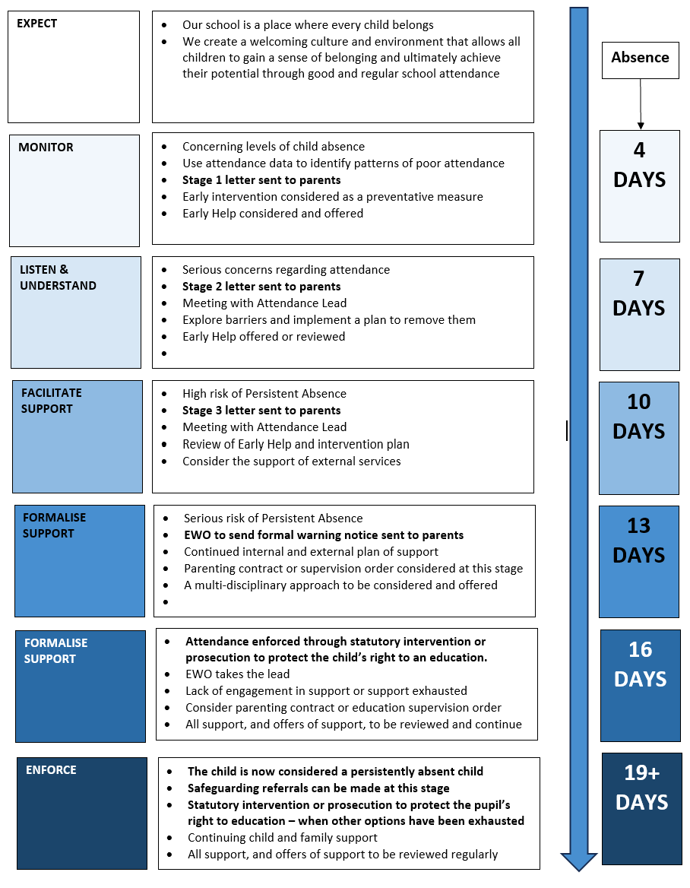

Protocol 3 – Daily Absence Procedures

Class teachers/ office/ support staff | Record on Arbor
Office team | Record on Arbor
Office team | Record on Arbor
Office team | Record on Arbor
SLT/ safeguarding team with Office | Record on Arbor
SLT/ safeguarding team | Record on CPOMS/ update registers if child’s reason for absence is known
SLT/ safeguarding team
SLT/ attendance team


- Protocol 4 – Tiered Approach to Attendance

Protocol 5 – Praise and reward systems
- Celebration assembly- Every Friday afternoon, best attending class for EYFS/KS1/KS2 receive the attendance trophy and their class teacher arranges additional playtime for all children in the class the following week.
- Within this assembly, 2nd place and 3rd place are also celebrated.
- School attendance board is displayed in school.
- Staff are expected to promote good attendance and punctuality with their classes regularly and should be excellent role models in this.
- Parent/Carer consultation meetings- information will be shared regularly with parents/carers about attendance and punctuality
- Attendance certificates are given for 100% attendance at the end of each half term

- Protocol 6 – Leave of absence forms

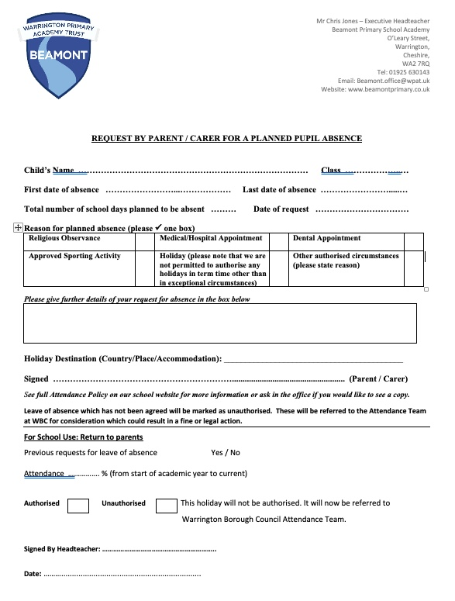

- Appendix 1
WPAT Pupil attendance and planned absence (Appendix to policy).

Definition of “exceptional circumstances” for term time holiday authorisation.

Legislative Framework:
It is a parent’s duty under Section 7 of the Education Act 1996, to ensure that their child of “compulsory school age” is to receive “an efficient, full time education”. A child is of compulsory school age from age five. A child should attend school from the start of term commencing on or after his / her fifth birthday. We, at WPAT, encourage good attendance from the day a child joins one of our schools.

Parents of registered pupils have a legal duty under Section 444 of the Education Act 1996 to ensure that children of compulsory school age attend school on a regular and fulltime basis. Permitting unauthorised absence from school is an offence and parents may be reported to the Trust, and other authorities, if problems cannot be resolved by agreement with the school.
School policies describe the required levels of attendance and punctuality for good progress to be made at school.

The government expects schools to:
    - Promote good attendance and reduce absence.
    - Ensure that every child has access to full time education to which they are entitled; and,
    - Act early to address patterns of absence.

The government also expects:
    - Parents to perform their legal duty by ensuring their children of compulsory school age, who are registered at school, attend regularly.

The Education (Pupil Registration) (England) (Amendments) Regulations 2013 have amended Regulation 7 of the 2006 regulations to prohibit the Headteacher of a school from granting leave of absence to a pupil except where an application has been made in advance and the Headteacher considers that there are exceptional circumstances relating the request. WPAT and its Headteachers believe it is necessary to define what we consider to be “exceptional circumstances” to give further structure to the decision to decline authorisation of absence.

WPAT have four permitted areas of “exceptional circumstance”:
    - The death or terminal illness of an immediate family member, where immediate is defined as the parents / carers and siblings of the child in school.
    - Absence recommended by a health professional.
    - Religious observance.
    - Allowances made for the families of service personnel on active duty.

In addition, we apply a further “threshold test” to the fundamental definition of “exceptional”. We believe that the circumstances must be, rare, significant, and unavoidable to qualify.
Where the Headteacher is satisfied that there are exceptional circumstances to warrant the request for leave of absence but has additional concerns about the timing of the absence, or the pupil’s attendance record, they may request a meeting with the parent / carer; the absence may not be authorised without attendance at this meeting.
If you require any further information or clarification, please refer your request to the school Headteacher via the school office.

Appendix 2
ATTENDANCE CODING
